IBEW LOCAL UNION 2213 SCHOLARSHIP APPLICATION
IBEW Local 2213 will award four $250 scholarships: TWO in the Western area, ONE in Central (to include Central North and South) and ONE in the Northeast. Any dependents of an active member in good standing of Local 2213 who have been accepted for enrollment as a full-time student at an accredited college are eligible to apply. Proof of enrollment is required along with a 500-word essay on “How the Union has affected my life.”
The deadline to apply is May 31, 2022
Winners will be chosen by the Executive Board in the form of a lottery drawing if all criteria are met. Please fill out the form below and return it with the essay and proof of college enrollment to our Union Office. The $250 will be paid directly to the recipient’s college.
IBEW LOCAL 2213 SCHOLARSHIP
6333 State Route 298
Suite 103
East Syracuse, NY 13057

Applicant Information
Full Name: ____________________________ ________________________________ ___________
Last First M.I.

Address: _____________________________________________________________ ____________
Street Address APT #/Unit #

______________________________________ ______________________ ____________
City State Zip Code

Phone: ______________________________ Email address: _____________________________

Parent’s Name ________________________________________________________________________

Parent’s Work Location: ________________________________________________________________

School Information

College Attending: _________________________

College Address: _________________________________

__________________________________

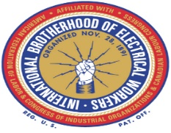

This Photo by Unknown Author is licensed under CC BY-NC-ND
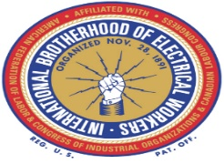
This Photo by Unknown Author is licensed under CC BY-NC-ND

